FOR PATIENTS:

TO CONNECT TO TELE-HEALTH SERVICE:

TIPS***
-Try and use the Chrome or Firefox browser for better connection
-Make sure your wifi connection is working

STEPS: (STEPS WITH PICTURES ON NEXT PAGE)
- Go to curewellmed.com
- On the middle of the home page, look for “Click here to connect to your provider” and click
- A new page should pop up (Doxy.me)
- Type in your full name and click “Check in”
- It will ask you to give access to your camera and microphone, click “Enable camera” and/or “Allow”
- When your provider is available, he or she will start the call. Please wait patiently.

Please login a few minutes early and try the “Precall Test” on the bottom left corner of the screen.

****MAKE SURE YOU ARE CLICKING ALLOW EVERYTIME TO GIVE ACCESS!

If you have any problems contact support@doxy.me

STEPS WITH PICTURES:

- Go to curewellmed.com

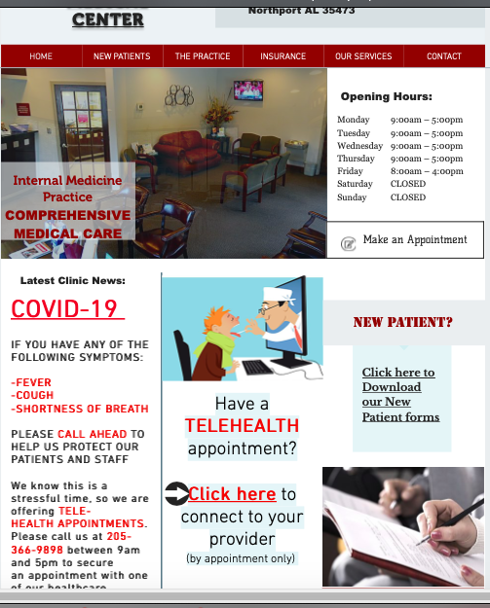

- On the middle of the home page, look for “Click here to connect to your provider” and click
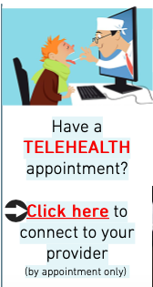

- A new page should pop up (Doxy.me)

- Type in your full name and click “Check in”
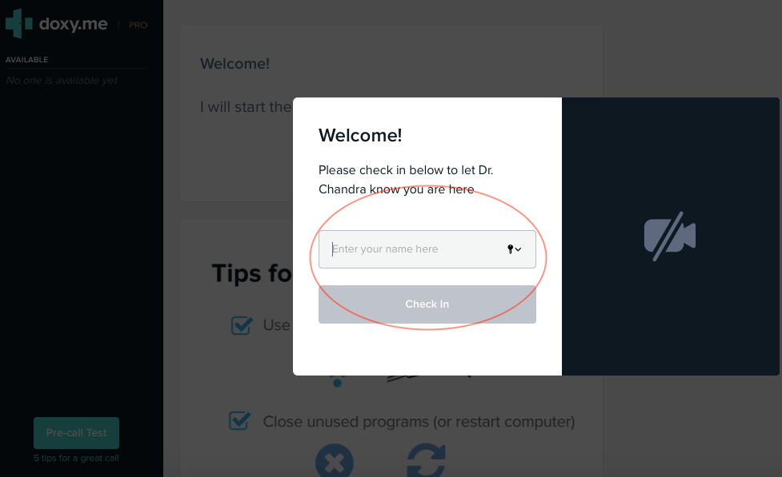

- It will ask you to give access to your camera and microphone, click “Enable camera” and/or “Allow”
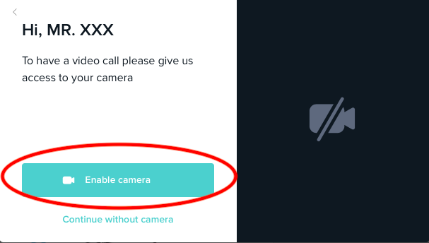
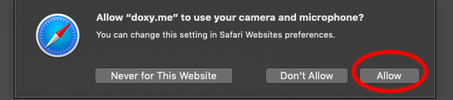

- When your provider is available, he or she will start the call. Please wait patiently.
If possible, try the pre-call test to make sure your audio and video is working

